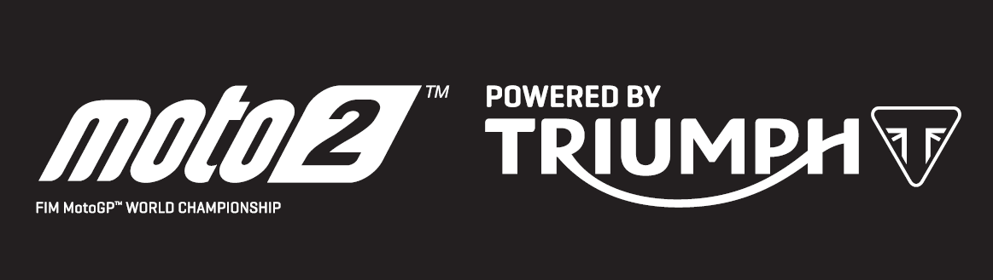

PRESS RELEASE

Fernandez takes Motul TT Assen Moto2 victory becoming the fourth winner in eight 2019 Moto2 races powered by Triumph

Augusto Fernandez took victory in Assen yesterday after a hugely exciting and drama-filled race in which championship hopefuls and previous series leaders Alex Marquez and Lorenzo Baldassarri both went down. Flexbox HP40 rider Fernandez has now taken podiums at three of the last five races, including his first win in Assen, to move to third in the championship.

In doing so, he also set another new lap record on his Triumph powered Kalex machine, continuing the clean sweep of lap and/or race records broken at every round of the 2019 Moto2 World Championship with Triumph’s 765cc triple.

Remy Gardner took his first pole position in qualifying and became the first Australian to do so in the intermediate category since Casey Stoner in 2005 at Phillip Island. He took his turn at leading the race, as did Sam Lowes, until both crashed out in separate circumstances.

It was Brad Binder who led for most of the race, until six laps from the end when a resurgent Marquez, who had dropped to 6th position in the opening laps, hit the front again and in typical fashion looked all set to run away with his fourth win in a row having really connected to the power and torque of the Triumph 765cc triple.

That wasn’t to be however, as Baldassarri, who himself was also riding a fantastic recovery having started 16th, lunged up the inside of Marquez as he looked to run a little wide and lost the front taking both championship contenders out of the race.

That paved the way for Fernandez, Binder and Luca Marini to move onto the podium, whilst a fourth place for Thomas Luthi moves the Swiss rider into a narrow lead at the top of the 2019 Moto2 championship, just 6 points ahead of Marquez. Marini is the highest-placed rider to have scored points at every race, lying in sixth position.

Steve Sargent, Triumph’s Chief Product Officer, said: “Well, what a race!! Incidents and overtakes came thick and fast in the Assen Moto2 round with Augusto Fernandez managing to navigate his way through it all to complete his maiden Moto2 win and Brad Binder getting his first podium finish in second. Fernandez is certainly a man on form having taken pole position in Spain and we have now had four different race winners so far this season.

As the season progresses and more riders dial themselves into the power and torque of the Triumph engine I am sure we will see more new faces at the front. After eight races we continue to see lap records being broken with a new race lap record in Assen. I’m very pleased to see that across the range of tracks and conditions we’ve experienced so far this season, our engines have helped redefine performance milestones at every race.”
The Triumph Moto2™ 765cc race engine is a development of the class-leading Street Triple RS 765cc road motorcycle and produces more than 140PS and the same visceral soundtrack.

Next up for the Moto2 series is the second in a back-to-back pairing of races at Sachsenring for the German Grand Prix on 7 July.
#PoweredByTriumph #TriumphOfficial

ENDS
For further information contact Tom Robinson on Tom.Robinson@Triumph.co.uk

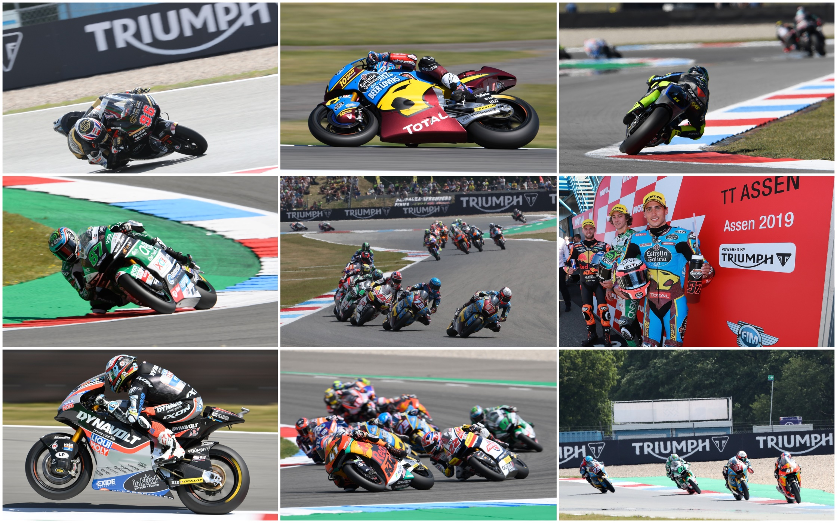
Notes to Editors
About Triumph

- The Triumph Moto2™ 765cc race engine is a development of the class-leading Street Triple RS 765cc road motorcycle and producing more than 140ps and the same visceral soundtrack.
- First established in 1902, Triumph Motorcycles celebrated 110 years of motorcycle manufacture in 2012. For more than three decades, Triumph Motorcycles has been based in Hinckley, Leicestershire, and has produced iconic bikes that perfectly blend authentic design, character, charisma and performance.

- Building around 65,000 bikes per year, Triumph is the largest British motorcycle manufacturer and has around 620 dealers across the world.

- This focus, innovation and engineering passion has today created a broad range of bikes suited to all motorcycle riders, including the iconic new Scrambler 1200, epic Speed Triple, the game changing all new Street Triple 765, the class defining Tiger 800, transcontinental Tiger 1200, iconic Triumph Bonneville family including the stunning Speed Twin, Bonneville Bobber, legendary Thruxton, accessible Street Twin, Street Scramble and iconic Bonneville T120 and T100, plus an exciting and accessible A2 range of Triumph motorcycles

- Triumph currently employs around 2,000 personnel worldwide and has subsidiary operations in the UK, North America, France, Germany, Spain, Italy, Japan, Sweden (Scandinavia), Benelux, Brazil, India and Thailand as well as a network of independent distributors. Triumph has manufacturing facilities in Hinckley, Leicestershire, and Thailand plus CKD facilities in Brazil and India.

- The Triumph Bonneville, famously named to celebrate Triumph’s 1956 land speed record on the Bonneville Salt Flats in Utah, USA, was the original British superbike and a race-winner straight out of the crate. Chosen by famous motorcyclists of the past for its legendary handling, style, and character. It’s that handling, character and style, married to modern rider-focused technology that makes the new Bonneville family THE authentic modern classic choice today.

- Triumph has a glorious racing history, competing in and winning races in almost every class and field of motorcycle sporting achievement. From winning the second ever Isle of Man TT in 1908, through to 1960s road and track domination in Europe and America, right up to contemporary racing achievements with the 675cc Triumph triple powered 2014 Daytona 200 win, the 2014 Isle of Man Supersports TT, 2014 and 2015 British Supersports titles and World SuperSport racing. And now with the new generation of 765cc triple engine powering the 2019 Moto2™ championship, Triumph’s racing legend continues.

